**The Science Behind IR Temperature Sensors and Their applications**

**Introduction:**

An infrared (IR) temperature measurement system consists of a sensor module, electronics, and an optomechanical system that guides IR radiation onto the sensor. IR sensing offers a non-contact method to measure the temperature of targets because all objects with a temperature above absolute zero emit IR radiation[1]. Infrared temperature sensing is an accurate alternative for measuring environmental temperature in mobile device applications. Infrared thermometers employ a lens to focus the infrared light emitted from the object onto a detector known as a thermopile. The simplest way to measure skin temperature is by using a thermistor or an IR temperature sensor[2].

**What is IR temperature sensor ?**

The temperature detection which is carried out by the thermal scanning with IR sensors has been considered to be the most efficient technique than any other technique because of its reliability, contactless in nature and fast response. The clinical data which contains the medical information about various persons are to be kept safe like the military records because these records should be very confidential. In order to store these records in safe condition the use of machine learning this handles the data carefully and stores it in the cloud [3].IR temperature sensors stands Infrared Radiation temperature which basically which detects the infrared radiation emitted from object . Each and every object above absolute zero temperature emits IR radiation . The sensor converts the infrared radiation reflected in the electrical signal and then this signal is converted in the form of temperature range . This is how the IR temperature sensors works. In that time face mask detector also left.it shows the 92% accuracy by face mask detection. The non contact temperature detection by Marco Dell and his colleagues made a uses of matrix of the sensors for precise temperature measurement of the temperature detection is improved to 89%. The non contact temperature measurement used by Marco Dell is based on the Stefan Boltamann law , this relates the maximum quantity of the energy . [4].

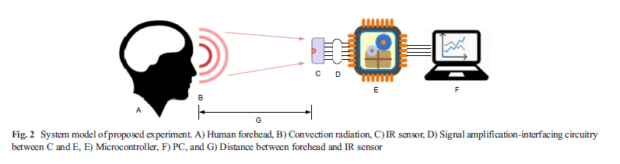

**Types of IR temperature sensor:**

1. **Thermopile Sensors:-these sensor contains the more number of thermocouple .which are connected in series because to find the infrared radiation . if they are connected in parallel then they not found the infrared radiation .these are basically used in industrial process monitoring ,etc**

2.Pyroelectric Sensors:- These sensors are basically used in motion sensor it is also used in generation of electric charge with the help of we can change the temperature.

3.Infrared Cameras (Thermal Imaging Cameras) :- These is the most advanced sensor .these create the image that image is based on infrared radiation which are emitted by objects.these are used in different application like firefighting and medical diagnostics.

**Real – life Application :**

1.manufacturing:- this process is stay with a temperature ranges and also maintain the product quality. it is also detect the signs of high temperature before they lead to failures. In industrial application base they can also be used for quality control and maintenance.

2.Medical Field:-IR temperature sensors, such those found in no-touch thermometers, are perfect for routine health checkups and fever screening because they deliver fast and reliable body temperature readings without requiring physical contact. Infrared sensors are used by laser equipment and some diagnostic devices to track and regulate working temperatures, ensuring proper and safe operation.

3.HVAC system:- HVAC stand for Heating ventilation and air conditioning . It is basically a monitoring system which monitors the temperature and alter the setting to setting accordingly to make it ideal climate control , IR sensors monitors and assist the regulation of heating ,ventilation and air conditioning system .

4. When it come to protect the environment , IR temperature sensors helps in monitoring weather , wildlife monitoring . pollution control , climate research and etc . which efficiently monitor and manage the environment

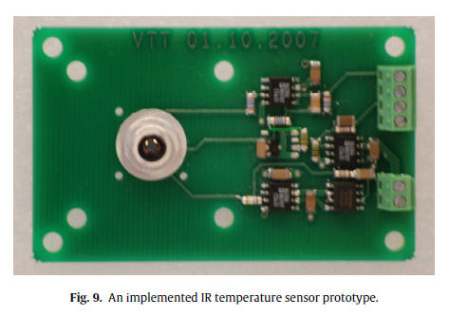

**Advantages of IR temperature sensor :**

The key attribute of proposed solution is the capability of raw data storage, graphical visualization, and thermo-graphic perception. The stored data could later be used for analysis of prospective occurrence of health-hazards. This solution would leverage portability, usability, and flexibility in one go.Wear-ability is other added advantage of such system.

1.Response time : IR sensor has a very quick response time which is in milliseconds . A sensors having a fast response time help the makes the sensor more reliable on real time monitoring. 2.High accuracy : More the accurately the sensor shows the temperature , its means it is more precise . The term precision is very crucial when it comes to temperature control system 3.safety: As IR temperature sensors allows us to measure the temperature from a distance . Due to this it reduces the risk of exposure to high temperature or dangerous unpredicted environmental changes

**Future scope of Infrared temperature sensors :**

1)Integration with the IOT and Smart Sensors : It enables IR sensors that provides real-time data, analytics by more sophisticated monitoring and control systems.

2) medical diagnostics : upgraded version of IR temperature sensors have a more advanced non contact medical diagnostics , result in giving more precise measurement of body temperature and thermal imaging for diagnostic .

3)Industrial Automation : IR is one of the important role in automation , it is use in quality control and process optimization .

4) Space exploration : satellite and spacecraft temperature monitoring : IR sensors is used for monitoring the temperature of craft component.

**Conclusion:**

They bring efficiency, safety, and precision to various fields, transforming how we measure temperature. IR temperature sensors are indispensable tools in modern technology, offering precise, non-contact temperature measurement across various industries. The traditional optomechanical design of the IR temperature measuring systems was shown to produce inaccurate results when directly ported into handheld mobile devices. this system could be transformed into a wearable one which may further relate to distributedwearable computing paradigm that in turn would benefit user to predict possible health disorder. Edge computing plays significant role in IoT applications where instant processing of data is required.

**References:**

1. Richmond, V.L., Wilkinson, D.M., Blacker, S.D., Horner, F.E., Carter, J., Havenith, G., and Rayson, M.P., Insulated skin temperatureasameasureof corebodytemperature for individuals wearing CBRN protective clothing. Physiol. Meas. 34(11):1531–1543, 2013.

2.Keränen, K., Mäkinen, J.T., Korhonen, P., Juntunen, E., Heikkinen, V. and Mäkelä, J., 2010. Infrared temperature sensor system for mobile devices. *Sensors and Actuators A: Physical*, *158*(1), pp.161-167.

3.Zhao, Yuanzhe, and Jeroen HM Bergmann. "Non-contact infrared thermometers and thermal scanners for human body temperature monitoring: a systematic review." *Sensors* 23.17 (2023): 7439.

4. Bonds, Q., Gerig, J., Weller, T.M., and Herzig, P., Towards Core

Body Temperature Measurement via Close Proximity Radiometric

Sensing. IEEE Sensors J. 12(3):519–526, 2012.

J.T. Cox, G. Hass, W.R. Hunter, Infrared reflectance of silicon oxide and magnesium fluoride protected aluminum mirrors at various angles of incidence from 8_m to 12_m, Appl. Opt. 14 (6) (1975) 1247–1250.